Navigating Dermatology for Muslim Patients

By: Maaz Haq (Second year medical student, Queen’s University) and Shaimaa Helal (Third year medical student, Queen’s University)

Studies done on samples of Muslim women in the United States suggest that up to 53% of Muslim women delay seeking care due to a perceived lack of availability of female physicians [1]. Canadian South Asian Muslims with end-stage kidney disease are less likely to receive a kidney transplant compared to their Caucasian non-Muslim counterparts [2]. Muslim women in Ontario have significantly lower rates of breast cancer and cervical cancer screening [3-4]. Skin cancer screening rates are also likely low. Given that skin cancer represents a third of all new cancer cases in Canada, this poses a significant public health issue. These health disparities arise when cultural and religious needs are not expressed and addressed.

Dermatology, with its focus on the examination of traditionally covered areas such as the skin and the scalp, may be nerve-racking for a Muslim to navigate. We have created this guide to empower Muslims with the knowledge of what is acceptable to request, which religious practices have medical relevance, and potential treatment considerations.

Addressing comfort during the medical encounter

The impermissibility of khalwa (seclusion with a member of the opposite gender) may prompt Muslims to request a same-gendered physician or the presence of a chaperone. Both are reasonable requests. If neither are possible, inform the physician of what they can do to make the experience more comfortable. For instance:
- Ask to expose the least amount of skin possible
- Ask for time to adjust your clothing/hijab without the physician present in the room
- Ask to postpone your physical exam until a same-gendered physician is available

Medically Relevant Details
There are certain Islamic practices which are relevant to concerns brought up in dermatology.
- Wudu and xerosis (dry skin)
Wudu (ablution) involves repeatedly washing the hands, face, arms, and feet throughout the day. This frequent washing of the skin, particularly in the presence of a pre-existing skin condition, can worsen dryness [5–7]. If you are unable to perform wudu safely, tayammum is a water-free alternative [8].
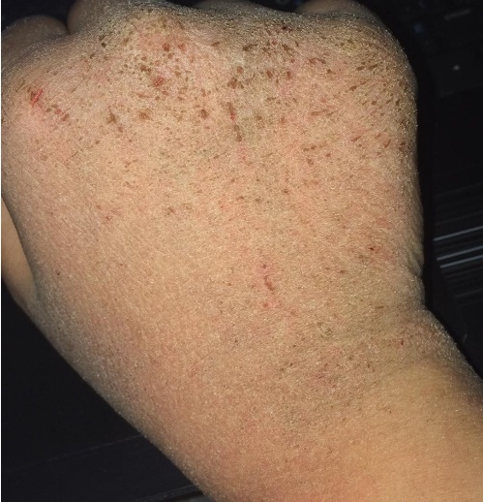
Courtesy of Muslim patient with wudu-exacerbated xerosis

- Hijab and hair care
Hijab is the Arabic word for ‘partition’ and refers to the religious attire worn by Muslims. The term is often used colloquially to refer to the headscarf worn by Muslim women. While hijab itself does not cause hair loss or thinning; improper hair care while wearing hijab can lead to hair thinning. This includes wearing synthetic fabrics that create friction leading to hair breakage [9], tying up hair tightly under your hijab leading to traction alopecia [10], or tying up hair while it is still wet [11]. Furthermore, women who observe hijab, particularly those living in northern climates, are at an increased risk of vitamin D deficiency which may impact your hair health [12-13]. Discussing your hair care practices with your dermatologist may help you recognize some possible reasons for hair thinning.

- The mark of sujood / “Devotion” sign
A small, darkened bump on the forehead of someone who regularly prostates on hard surfaces is usually benign. If unfamiliar with the practice, a dermatologist may wonder what created this sign.
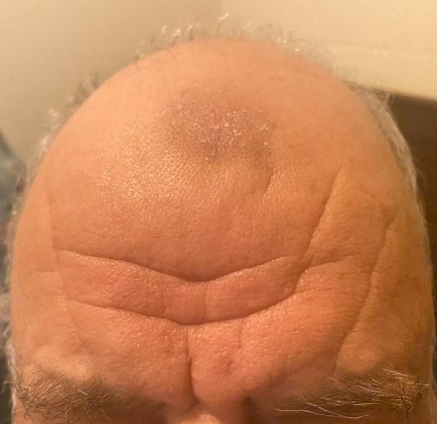
Courtesy of Muslim patient with the ‘devotion’ sign

Tailoring Treatment
Dietary Restrictions
Muslims may have preferences for medications due to religious dietary restrictions. Within Islamic dietary laws, halal refers to ingredients and foods that are deemed religiously permissible for consumption and haram refers to ingredients that are deemed religiously impermissible for consumption. Things that are classified as haram can become permissible in extenuating circumstances, such as a lack of availability of an equally effective halal alternative, or a life-threatening emergency that requires prompt action. There are a variety of ingredients that may be included in medications which a Muslim may choose to avoid.

These include:
- Porcine-derived ingredients*
- Non-halal animal-derived ingredients*
- Alcohol when orally administered

*For a full list of animal-derived medications, visit: bit.ly/animal-derived-meds

Treatment Regimens in Ramadan
If you are fasting during Ramadan, you may want to ask your dermatologist if they can accommodate your treatment regimen around fasting hours. This may also apply for topical medications as a study in the UK showed that over a third of Muslim patients do not use topical dermatologic treatments while fasting [14]. Your dermatologist can work with you to find a treatment schedule that works.

Treatment plans work best when both patients and physicians are involved in the decision-making process. As a patient, this means being proactive by doing your own research and coming prepared to discuss your treatment preferences.

Conclusion
Empowering yourself with information about the intersection of your faith and health allows you to come to appointments equipped to ask the right questions. Sharing your religious needs and health preferences helps open-up a conversation to allow shared decision making and enhances not only your comfort, but your quality of care.

[1] M. Vu, A. Azmat, T. Radejko, and A. I. Padela, “Predictors of Delayed Healthcare Seeking Among American Muslim Women,” J. Women’s Heal., vol. 25, no. 6, pp. 586–593, Jun. 2016, doi: 10.1089/jwh.2015.5517.
[2] A. Ali et al., “South Asian and Muslim Canadian Patients are less Likely to Receive Living Donor Kidney Transplant offers Compared to Caucasian, Non-Muslim Patients,” Transplantation, vol. 102, p. S502, Jul. 2018, doi: 10.1097/01.tp.0000543324.75699.94.
[3] M. Vahabi et al., “Breast cancer screening utilization among women from Muslim majority countries in Ontario, Canada,” Prev. Med. (Baltim)., vol. 105, pp. 176–183, Dec. 2017, doi: 10.1016/j.ypmed.2017.09.008.
[4] A. K. Lofters, M. Vahabi, E. Kim, L. Ellison, E. Graves, and R. H. Glazier, “Cervical Cancer Screening among Women from Muslim-Majority Countries in Ontario, Canada,” 2017, doi: 10.1158/1055-9965.EPI-17-0323.
[5] A. P. Lazar and P. Lazar, “Dry skin, water, and lubrication,” Dermatologic Clinics, vol. 9, no. 1. pp. 45–51, Jan. 01, 1991, doi: 10.1016/s0733-8635(18)30432-7.
[6] M. Greenberg, H. Galiczynski, and J. Edward M. Galiczynski, “Dry skin: common causes, effective treatments: ruling out systemic causes is the first step to diagnosing xerosis, and patient education is the key to management. The good news is that dry skin can usually be managed effectively and inexpensively,” JAAPA-Journal Am. Acad. Physicians Assist., vol. 17, no. 9, pp. 26–31, Sep. 2004, Accessed: Aug. 06, 2020. [Online]. Available: https://go.gale.com/ps/i.do?p=AONE&sw=w&issn=15471896&v=2.1&it=r&id=GALE%7CA123079399&sid=googleScholar&linkaccess=fulltext.
[7] E. Proksch and J. M. Lachapelle, “The management of dry skin with topical emollients - Recent perspectives,” JDDG - Journal of the German Society of Dermatology, vol. 3, no. 10. J Dtsch Dermatol Ges, pp. 768–774, Oct. 2005, doi: 10.1111/j.1610-0387.2005.05068.x.
[8] Sahih al-Bukhari 334
[9] A. Shafik, “Polyester but not cotton or wool textiles inhibit hair growth,” Dermatology, vol. 187, no. 4, pp. 239–242, 1993, doi: 10.1159/000247256.
[10] V. Billero and M. Miteva, “Traction alopecia: The root of the problem,” Clinical, Cosmetic and Investigational Dermatology, vol. 11. Dove Medical Press Ltd., pp. 149–159, Apr. 06, 2018, doi: 10.2147/CCID.S137296.
[11] C. R. Robbins, Chemical and Physical Behavior of Human Hair. Springer Berlin Heidelberg, 2012.
[12] M. Razzaghy-Azar and M. Shakiba, “Assessment of vitamin D status in healthy children and adolescents living in Tehran and its relation to iPTH, gender, weight and height,” Annals of Human Biology, vol. 37, no. 5. Taylor & Francis, pp. 692–701, Sep. 2010, doi: 10.3109/03014460903527348.
[13] S. Hatun et al., “Subclinical vitamin D deficiency is increased in adolescent girls who wear concealing clothing,” in Journal of Nutrition, 2005, vol. 135, no. 2, pp. 218–222, doi: 10.1093/jn/135.2.218.
[14] T. Patel, A. Magdum, and V. Ghura, “Does fasting during Ramadan affect the use of topical dermatological treatment by Muslim patients in the UK?,” Clin. Exp. Dermatol., vol. 37, no. 7, pp. 718–721, Oct. 2012, doi: 10.1111/j.1365-2230.2012.04403.x.

